**Headache**

**Initial Assessment**

|  |  |  |
| --- | --- | --- |
| **Presenting Symptom/Chief Complaint** | | |
| Patient is presenting with chronic headache at the whole head area due to overwork, worsening on the afternoon, rising with leaning down and sleep. | | |
| **Main Signs and Symptoms** | | |
| Patient having headache symptom that worsening at the afternoon time and evening. | | |
| **Other Signs and Symptoms** | | |
| Otherwise the patient healthy strong. Have difficulties with regular eating. | | |
| **TCM Diagnosis and Treatment (identified TCM disease, TCM differentiation of syndromes)** | | |
| Headache at the eveningand after a workday. Due to Qi and blood deficiency and wrong with rest and sleep. (Western tension headache) | | |
| **Treatment Principles and Strategies** | | |
| ↑Blood flow to the head and brain. Nourish ↑ Qi flow at the head area. ↑ Level of physical activities and rest. | | |
| **Treatment Plan (Modalities; acupuncture, herbal, dietary, manual therapies), frequency and duration** | | |
| Acupuncture 2 times a week with combination of local and distal points with root treatment. Qi and blood tonification with gradually disappear of the headache. Combination of short period of concentration, alternating with often snacks and rest. | | |
| **Any other Advice Given to Patients** | | |
| Acupuncture: Du23, GB14 (L.R.), GB8 (L.R.), L47 (L.R.) with reduction method. UB10 (L.R.)  UB 16 – acupressure with combination of Du20 and UB20 (L.R.). Peripheral points of stomach channel: St43 (L.R.), St44 (L.R.). Reduce the headache. Du20 with sedation + 4 extra 21 points, UB60 (sedation L.R.), St 3 (R.L.) with combination of UB62. Stimulates the breather Yang area and opening the governing vessel. ↑Physical activity, gradually attention to food consumption in time. | | |
| **Practitioner:** | **Date:** | **Signature:** |

**Headache**

**Daily Charting____________________________________Patient Name:**

**Date: November 03, 2015**

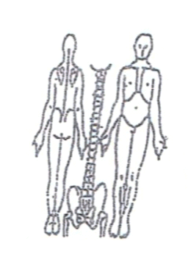 **Working Diagnosis:** Headache due to Qi and blood deficiency

(tension headache).

S: Patient has the dull headache at the afternoon (at the end of working day). Low energy level.

O:

Treatment (P) Acupuncture: Du23, GB14 (L.R.), GB8 (L.R.), L47 (L.R.) with reduction method. UB10 (L.R.) UB 16 – acupressure with combination of Du20 and UB20 (L.R.). Peripheral points of stomach channel: St43 (L.R.), St44 (L.R.). Reduce the headache. Du20 with sedation + 4 extra 21 points, UB60 (sedation L.R.), St 3 (R.L.) with combination of UB62. Stimulates the breather Yang area and opening the governing vessel. ↑Physical activity, gradually attention to food consumption in time.

(A) Acupuncture with local points. Sedation following by tonification 1 hour due to protocol.

**Date: ________________**

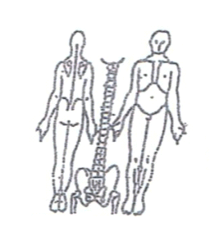**Working Diagnosis:**

S: Patient still experience the dull headache at the end of the day. Much better

with diet and energy during the day.

O:

Treatment (P) Acupuncture 1 hour according protocol.

(A)

**Date ______________**

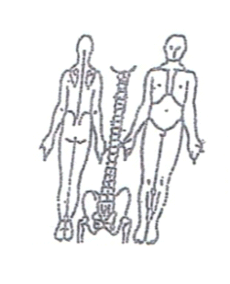**Working Diagnosis:**

S: Patient has N energy level. N sleep. No headache during the day. No muscle

spasm at the rest of the day.

O:

Treatment (P) Acupuncture with warmed needles 1 hour due to protocol.

(A)

**Date: ______________**

**Working Diagnosis:**

S: Patient has N energy level. N sleep. No headache during the day. No muscle

spasm at the rest of the day.

O:

Treatment (P) Acupuncture with warmed needles 1 hour due to protocol.

(A)

**Date:_ _______________**

**Working Diagnosis:**

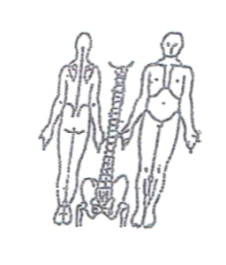

S: Patient has no headache for the day. N sleep, N level of energy during the day. Paying much more attention to altering mental concentration with small period of movement.

O:

Treatment (P) Acupuncture 1 hour according to the protocol.

(A)